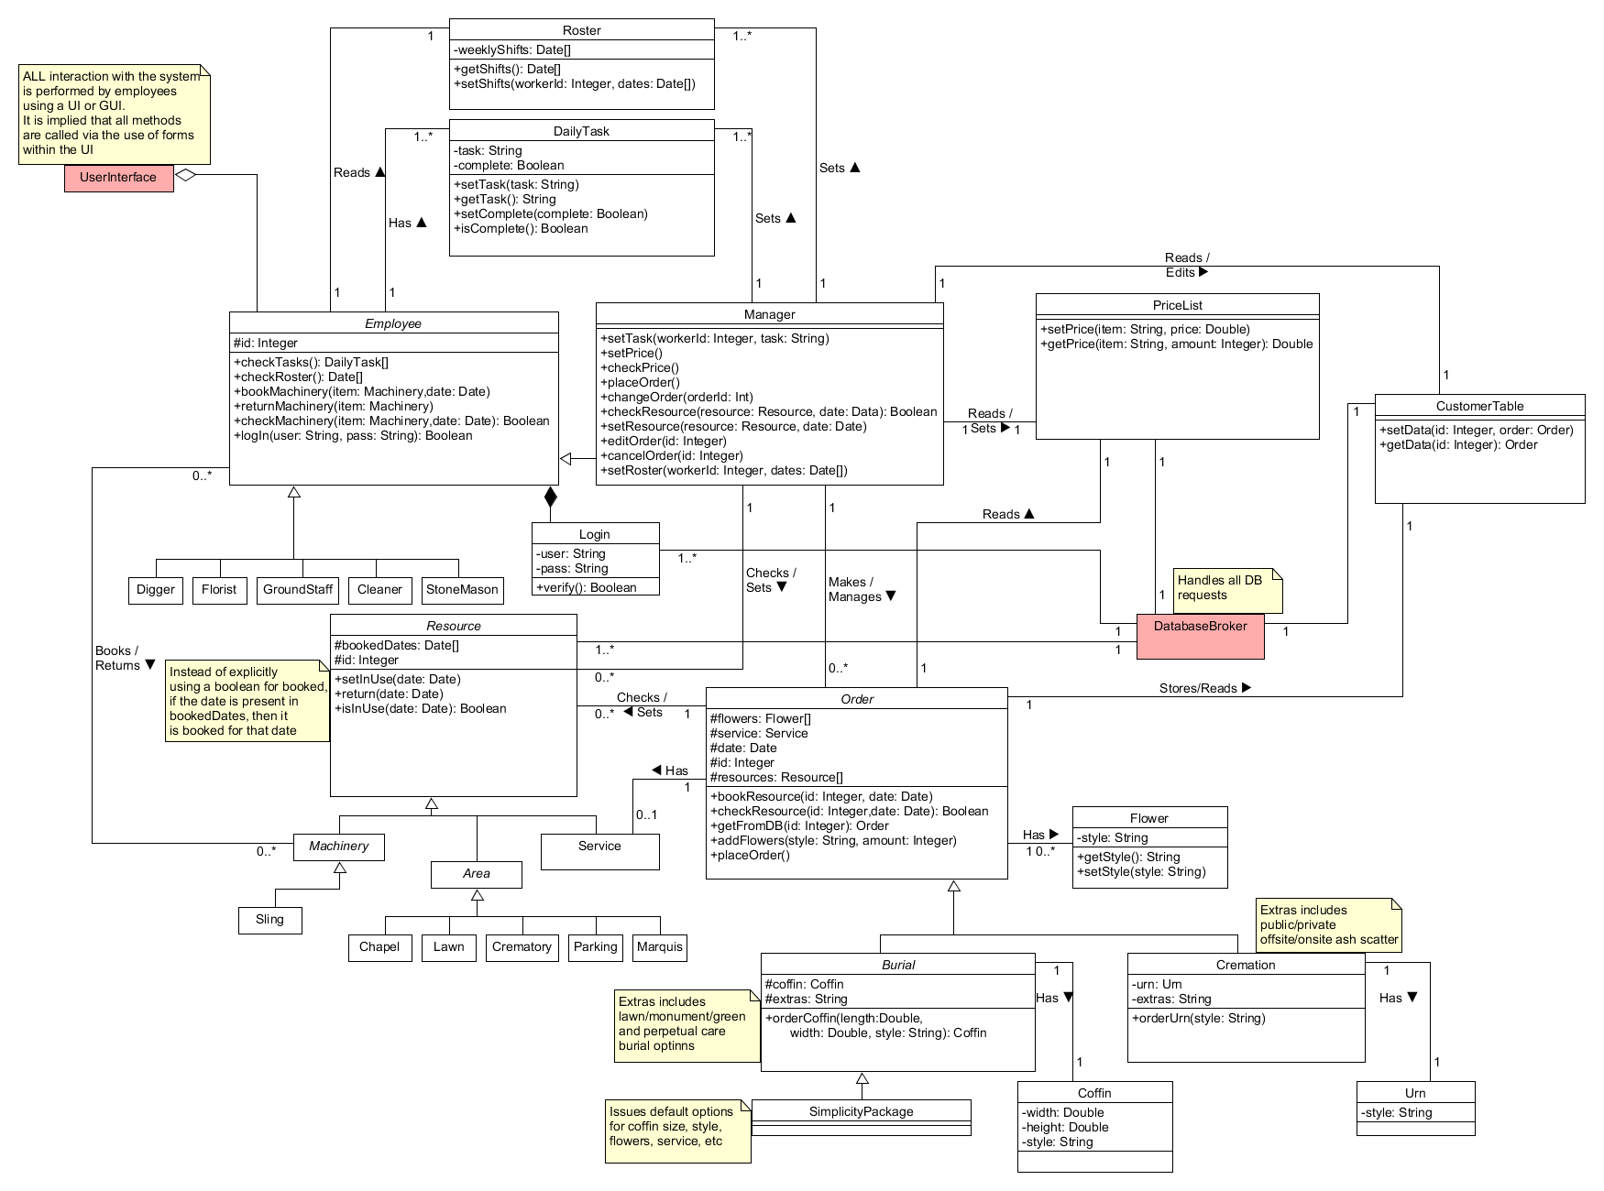

Roster -Weekly Shifts: Datel +getShifts(): Dates +setShifts(workerld: Integer, dates: Datel)

ALL interaction with the system is performed by employees using a Ul or GUI. It is implied that all methods are called via the use of forms within the UI

Sets

Userinterface

Reads

Daily Task -task: String -complete: Boolean +setTask(task: String) +getTask(): String +setComplete(complete: Boolean) +isComplete(): Boolean

Has

Sets A

Fonds

Reads/ Edits

PriceList +setPrice(item: String, price: Double) +getPrice(item: String, amount Integer): Double

Employee #id: Integer +checkTasks(): Daily Taski +checkRoster(): Datel +book Machinery(item: Machinery,date: Date) +returnMachinery(item: Machinery) +checkMachinery(item: Machinery, date: Date): Boolean +login(user. String, pass: String): Boolean

Manager +setTask(workerld: Integer, task: String) +SetPrice() +checkPrice() +placeOrder() +change Order(orderld: Int) +checkResource(resource: Resource, date: Data): Boolean +setResource(resource: Resource, date: Date) +editOrder(id: Integer) +cancelOrder id: Integer) +setRoster(workerld: Integer, dates: Date[])

CustomerTable

Reads / 1 Sets 1

+setData(id: Integer, order: Order) +getData(id: Integer): Order

Reads A

Login -user: String -pass: String +verify(): Boolean

1..

Digger

Florist

GroundStaff

Cleaner

Checks / Sets /

Stone Mason

Makes/ Manages /

Handles all DB requests

DatabaseBroker

Books/ Returns

Resource #bookedDates: Date]

#id: Integer Instead of explicitly

+setInUse(date: Date) using a boolean for booked,

"+return(date: Date) if the date is present in

+isinUse(date: Date): Boolean booked Dates, then it is booked for that date

0.*

Stores/Reads

Checks/ 0..* Sets

1

Has

Order #flowers: Flower #service: Service #date: Date #id: Integer #resources: Resource] +bookResource(id: Integer, date: Date) +checkResource(id: Integer date: Date): Boolean +getFromDB(id: Integer): Order +addFlowers(style: String, amount: Integer) +placeOrder)

10.

*Machinery*

Michigay

Service

Has 10.

ko

Flower -style: String +getStyle(): String +setStyle(style: String)

**Area**

Sling

La

ChapelLawn

Crematory

Extras includes public/private offsite/onsite ash scatter

Chapel

**Lawn**

Crematory

Parking Margul

Parking

Marquis

Burial #coffin: Coffin #extras: String +orderCoffin(length: Double,

width: Double, style: String): Coffin

Cremation -urn: Un -extras: String +orderurn(style: String)

Extras includes lawn/monument/green and perpetual care burial optinns

Has

Urn -style: String

SimplicityPackage

Coffin -width: Double -height: Double -style: String

Issues default options for coffin size, style, flowers, service, etc